 

OPEN ENDED ASSIGNMENT REPORT

“STICK FOR BLIND”

Subject : EMBEDDED SYSTEMS

Prepared By

2246:-Vaishnavi Shirsalkar

2247:-Anushka Shirsath

2248:-Shivani Patil

2249:-Nidhi Shivapuji

2250:-Shreya Jadhav

* Batch : B3
* Group Number : 2
* Title of the open assignment : STICK FOR BLIND

Objective : To design and simulate a for visually impaired persons using microcontroller in proteus .

Paper Design :

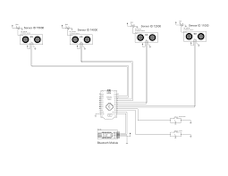

COMPONENTS :

Following are the components selected : -

1. ARDUINO

Arduino is an open-source electronics platform based on easy-to-use hardware and software. Arduino boards are able to read inputs - light on a sensor, a finger on a button, or a Twitter message - and turn it into an output - activating a motor, turning on an LED, publishing something online.

1. PIR SENSOR:-

Passive infrared (PIR) sensors use a pair of pyroelectric sensors to detect heat energy in the surrounding environment. These two sensors sit beside each other, and when the signal differential between the two sensors changes (if a person enters the room, for example), the sensor will engage

1. ULTRA SONIC SENSOR

HC-SR04 SENSOR FEATURES

operating voltage: +5v

theoretical measuring distance: 2cm to 450cm

practical measuring distance: 2cm to 80cm

accuracy: 3mm

measuring angle covered: <15°

operating current: <15ma

operating frequency: 40hzyou can buy[hc-sr04 ultrasonic sensor](https://quartzcomponents.com/products/hc-sr04-ultrasonic-sensor-module) from here.

1. BUZZER

a small buzzer is a common feature in electronic products and can provide an effective wayof interacting with users or raising an alarm.depending on the type and strength of the signals available to drive the buzzer, the physicalspace available, and the required audio sound pressure level (spl), a magnetic or piezoelectrictype will be the most common options for your application

*WORKING*:

The smart blind stick automatically detects the obstacle in front of the person and give him a response to the person by vibrating the stick and also with a warning sound. Through this, the blind person can aware about the obstacles in front of him. I used Ultrasonic sensor for detecting the obstacles.

## Working on the Smart Blind Stick

* The **Smart Blind Stick** scans the path in front of it with the help of an [**HC-SR04** Ultrasonic sensor](https://techatronic.com/what-is-ultrasonic-sensor-ultrasonic-sensor-working-hc-sr-04/).
* Whenever the sensor detects any object in its path the buzzer starts beeping and also at the same time the LED turns on.
* The blind person can hear the beeping of the buzzer and manage to change the way. In this way, the person can easily find his way without getting injured.
* This smart stick works in the same way as the [Ultrasonic range finder](https://techatronic.com/ultrasonic-range-finder-using-arduino-lcd/) did. You can also see the real-time values of the distance in cm on the Arduino serial monitor.

Screenshots of Proteus simulation :

1)INTERFACING DIAGRAM:-

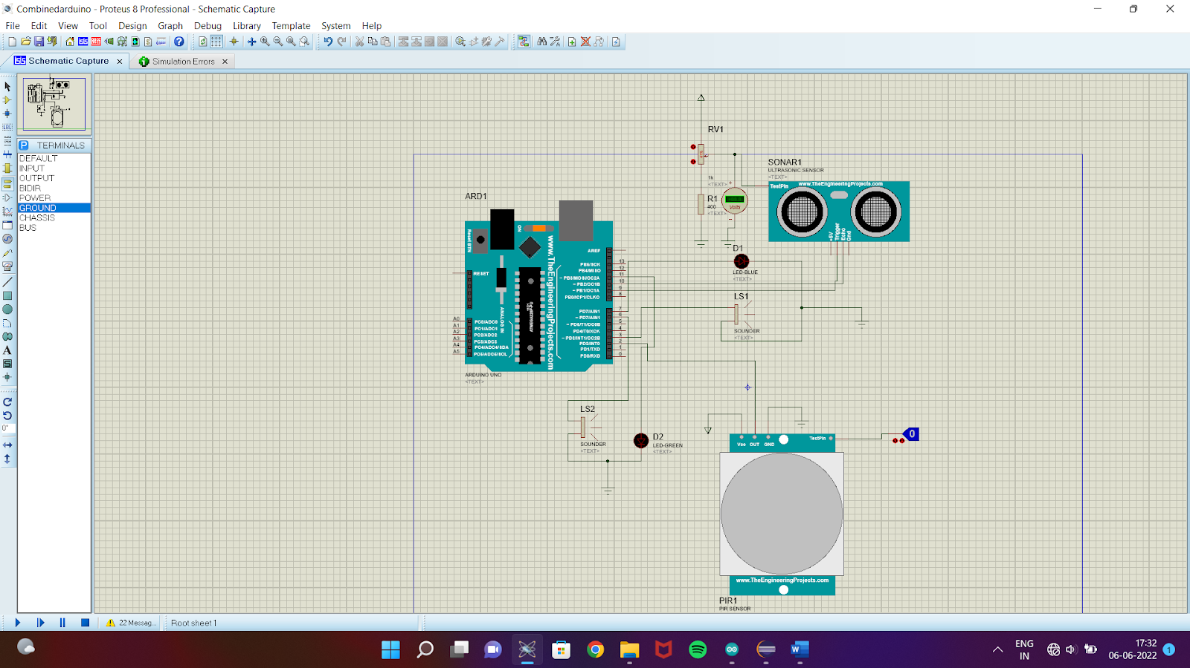

2) PIR SENSOR OUTPUT:-

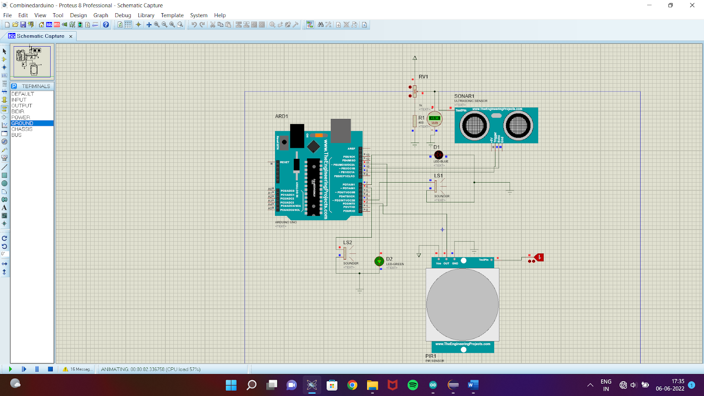

3)ULTRA SONIC SENSOR OUTPUT:-

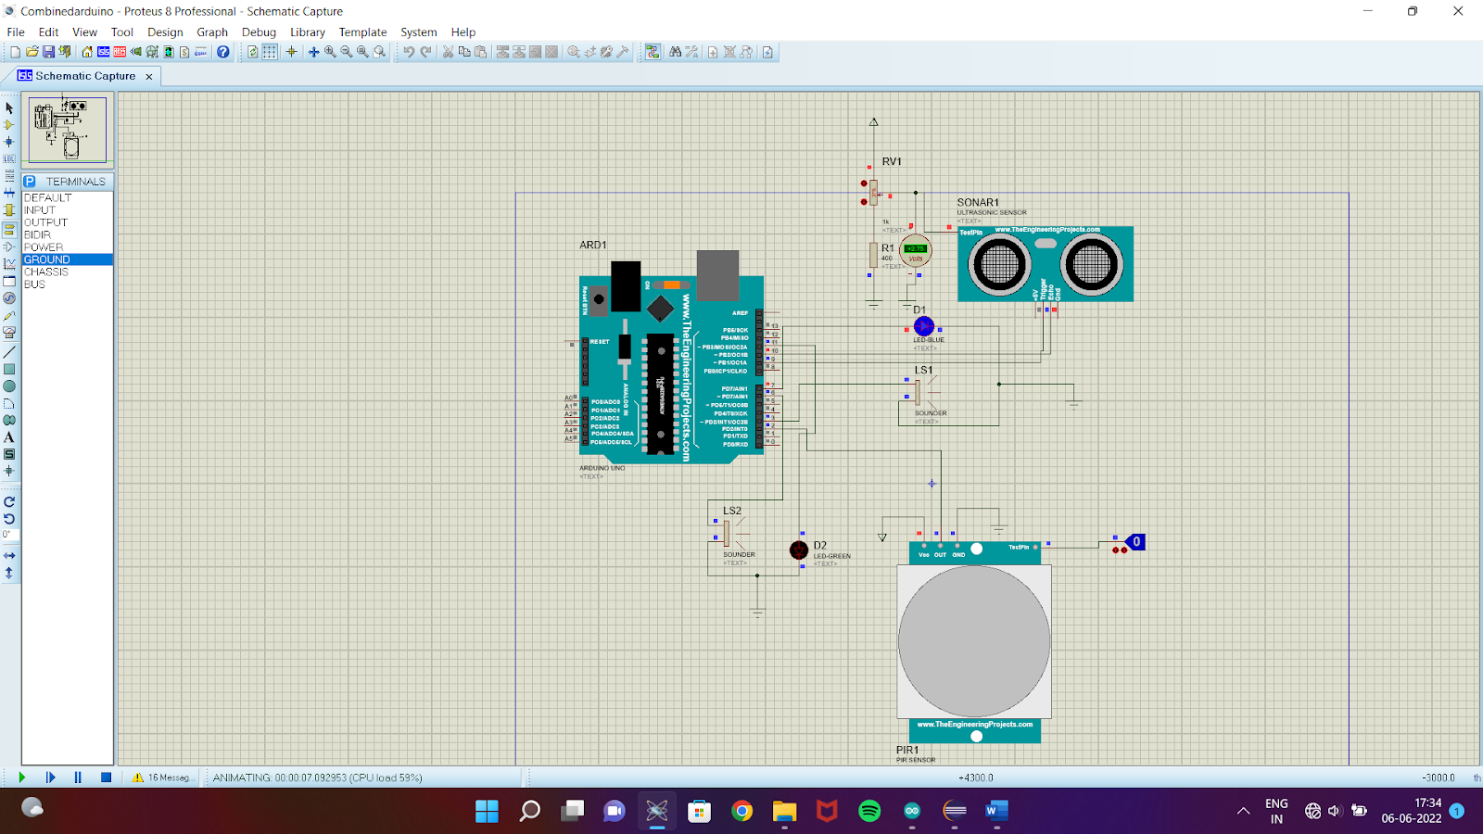

Conclusion : The Smart Stick acts as a basic platform for the coming

generation of more aiding devices to help the visually

impaired to be more safe. It is effective and afford. It leads to

good results in detecting the obstacles lying ahead of the user

in a range of four meters, detecting stairs and water pits.

This system offers a low-cost, reliable, portable, low-

power consumption and robust solution for navigation with

obvious short response time. Though the system is hard-wired

with sensors and other components, it's light in weight. Further

aspects of this system can be improved via wireless

connectivity between the system components, thus, increasing

the range of the ultrasonic sensor and implementing a

technology for determining the speed of approaching

obstacles. While developing such an empowering solution,

visually impaired and blind people in all developing countries

were on top of our priorities.